**Weekly Progress Report Template**

Project Title: Flexi-Craft

Group ID: 2021-CS-09, 2021-CS-11, 2021-CS-41

Student Name: Ayesha Nadeem, Yahya Mirza, Muhammad Hamza

Supervisor Name: Sir Atif Hussain Warraich

Week Number: 08

Date: 10/27/2024

Supervisor Comment and Sign:

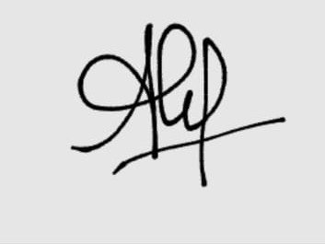

**1. Summary of Work Done**

* **Dataset Research and Preparation**: Extensive dataset search was conducted using Hugging Face, though initial results showed the data to be highly unstructured. Given the dataset's size of 370 GB, challenges with downloading and handling in parquet format were encountered. Work continues on filtering and structuring the data for effective use.
* **Model Fine-Tuning**: Progress was made in tuning the model, with plans to commit the dataset in JSON format after mid-week review. This tuning effort is part of an ongoing effort to optimize output quality for improved relevance and accuracy.
* **Frontend Development**: Completed the sign-up, sign-in, and landing page functionalities, contributing to a more seamless user experience on the platform.

**2. Challenges Faced**

* **Data Complexity**: The dataset sourced from Hugging Face required extensive filtering due to its unstructured nature. Handling such a large volume (370 GB) in a structured format posed additional challenges.
* **Data Diversity in Fine-Tuning**: Ensuring a diverse range of user inputs and scenarios in the dataset proved challenging, as the initial dataset lacked sufficient variation, which could potentially lead to biased model outputs.

**3. Solutions or Workarounds**

* **Dataset Structuring**: Emphasis was placed on filtering and restructuring the dataset into a parquet format for efficient handling, with plans to convert to JSON for commit purposes.
* **Diversity Enhancement**: Efforts were made to expand data sources and include a broader range of examples. This enhancement aimed to ensure the model was trained on a more comprehensive set of scenarios, leading to a more generalized model output.

**4. Tasks Planned for Next Week**

* **Refinement of Model Fine-Tuning**: Continue refining the fine-tuning process to improve the model's output quality.
* **Implementation of Collaborative Editing**: Begin work on integrating collaborative editing functionalities, enhancing the platform's utility for teams working on web templates.
* **Built-in Components:** Start working on components library/ pre-built components.

**5. Progress Against Timeline**

Currently on track with the project timeline. Two tasks are going parallel planning with the congeries of the requirements and the targets set in the Gantt Chart.

**6. Additional Notes**

For now, there's no any need of resources required.